Advanced Algebra 2 Name : __________________________ Period: _____
Unit 1 Reassessment (90 is the highest possible grade)
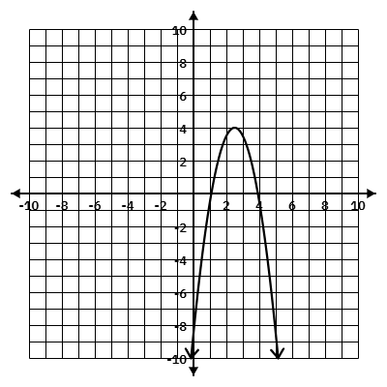
For problems 1-3, use the provided graphs to determine all requested information.
Domain (inequality): ___________________

Range (inequality): ____________________

Max: _____________ OR Min: ___________

x-intercept(s): ________________________

y-intercept: _________________

Parent Function Family: _______________
1.

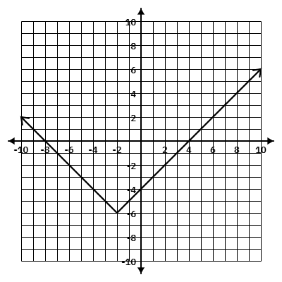
2.
Domain (set): ___________________

Range (set): ____________________

Max: _____________ OR Min: ___________

x-intercept(s): ________________________

y-intercept: _________________

Parent Function Family: _______________

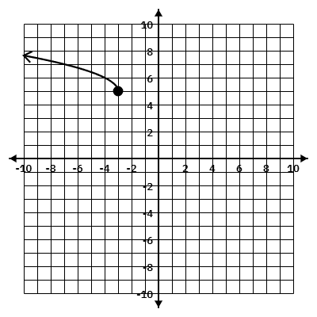
3.
Domain (interval): ___________________

Range (interval): ____________________

Max: _____________ OR Min: ___________

x-intercept(s): ________________________

y-intercept: _________________

Parent Function Family: _______________

4. The population P (in thousands) of a town since 2000 is given by the function P(t)=1.2t+50, where t is the number of years since 2000. What would a reasonable domain be for this situation?
a) (−∞,∞)
b) [5,∞)
c) [0,∞)
d) All real numbers
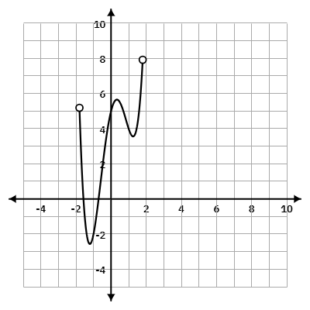
5. Consider the following graph:

Which value is in the range of the function, but is not in its domain?
a) -1
b) 3
c) 1
d) 0

6. A coffee shop owner uses the function C(n), where n is the number of customers served, to model the total cost of running the shop for a day.
A reasonable domain for this function would be:
- both positive and negative integers
- positive real numbers
- positive integers and zero
- both positive and negative real numbers

7. The graph below shows the height of a ball that is thrown into the air over a period of time.
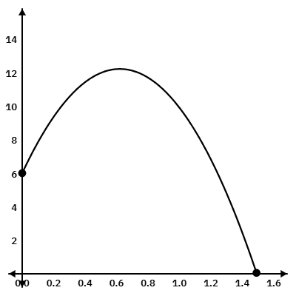
- How many seconds after the throw did the ball reach its maximum height? ______________

- How long did it take the ball to reach the ground? ______________

- What does the y-intercept represent in this situation?

- What does the x-intercept represent in this situation?

8. Which of the following represent a linear function? Circle all that apply:

a) $y=-2x+5$

b) $y=\left|x-1\right|$

c) The perimeter P of a square with side length s is P=4s.

d) $f(x)=-{2x}^{2}$

e) $y=\sqrt{x-3}$

